**Fitness Buddy- Your AI-powered health and fitness companion**

**Steps to Create Fitness Buddy – Agent AI**

**Presented By:**

1. **Esha Singh- Vivekananda Institute of Professional Studies- Vivekananda School of Information Technology (VSIT)**

**Problem statement:** Fitness Buddy

The challenge - In today’s fast-paced world, many individuals struggle to maintain a healthy lifestyle due to a lack of personalized guidance, time constraints, and inconsistent motivation. Traditional fitness solutions often require expensive subscriptions, in-person consultations, or rigid schedules that don't adapt to personal preferences or daily routines. There is a growing need for an accessible, friendly, and intelligent virtual assistant that can provide on-demand fitness advice, healthy lifestyle suggestions, and basic nutrition guidance—all tailored to individual needs and available at any time. Fitness Buddy aims to solve this problem by offering a conversational, AI-powered health and fitness coach that can:

Recommend home workouts and routines based on user input.

· Provide motivational tips and daily fitness inspiration.

· Suggest simple, nutritious meal ideas.

· Encourage habit-building and consistency.

Technology: Use of IBM Cloud Lite services /IBM Granity is mandatory

**Proposed Solution**

* **Title:** AI-Powered Fitness Buddy Using IBM Watsonx.ai
* **Solution Overview:**
  + A conversational AI agent built on IBM Watsonx.ai to provide personalized fitness guidance, nutrition plans, and motivational support.
  + Leverages Mistral-large foundation model and agentic AI for dynamic interactions.
* **Key Features:**
  + Dynamic Workouts: Recommends routines based on time, equipment, and goals (e.g., *"20-min home workout with no equipment"*).
  + Nutrition Guidance: Suggests meal plans with dietary restrictions (e.g., *"gluten-free lunch under 500 calories"*).
  + Motivational Support: Provides habit-building tips and quotes (e.g., *"30-day challenge for consistency"*).

1. Log in to IBM Cloud.

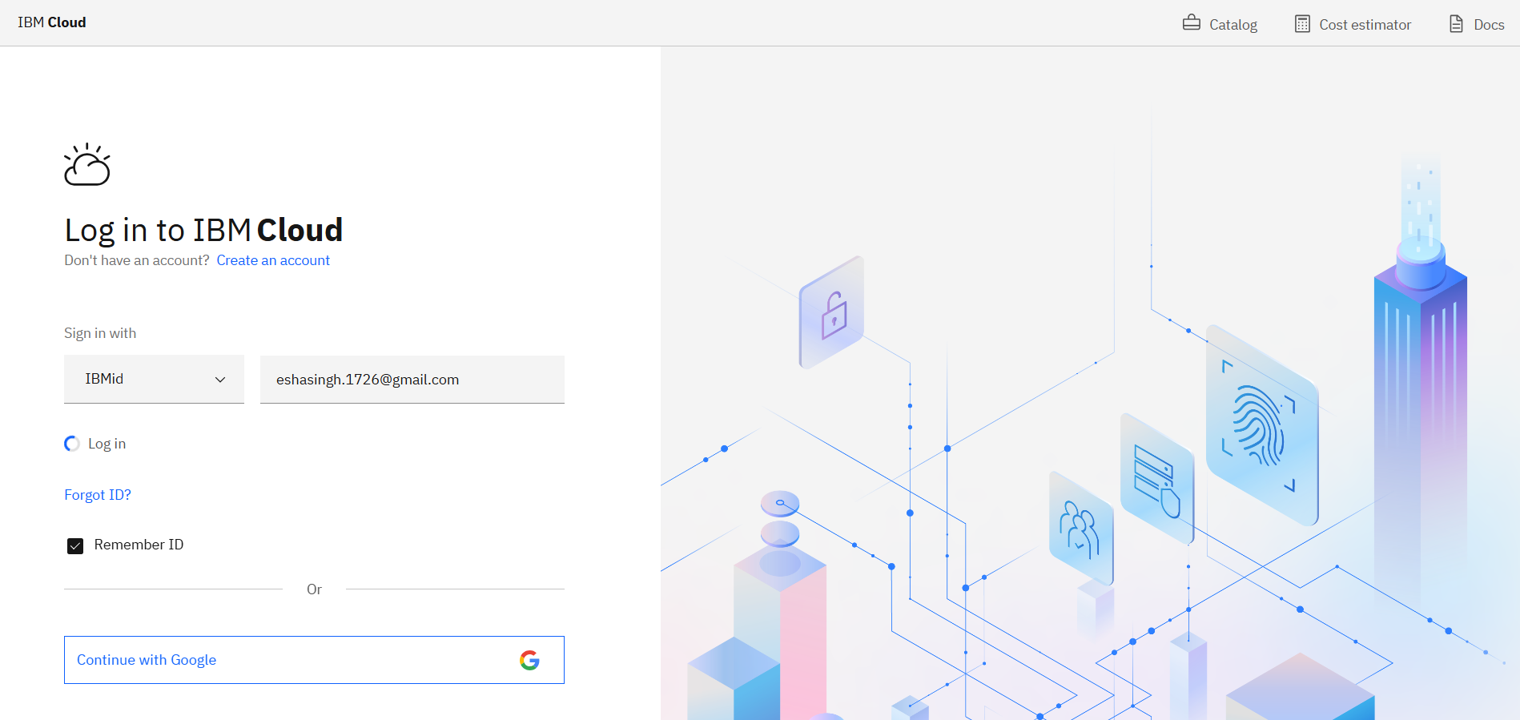

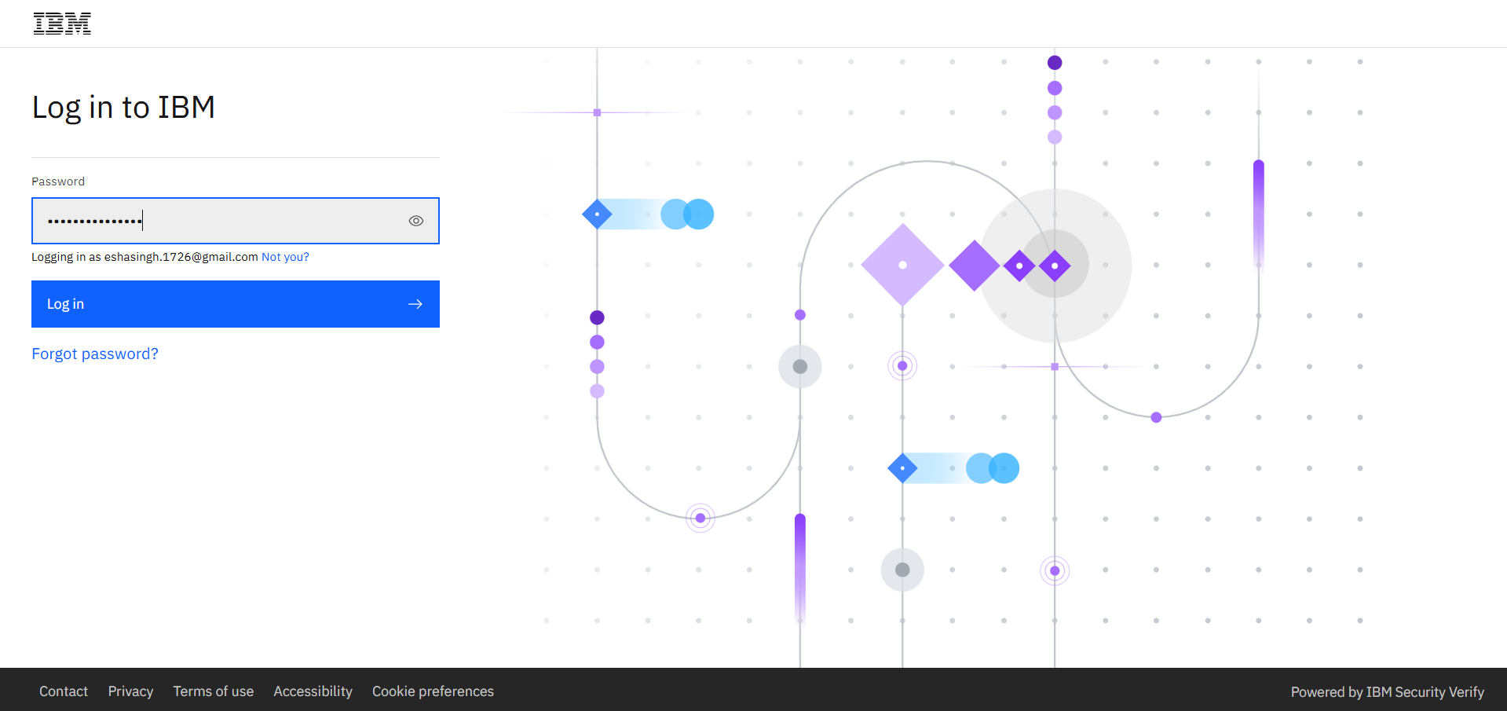

1. Delete all the resources.

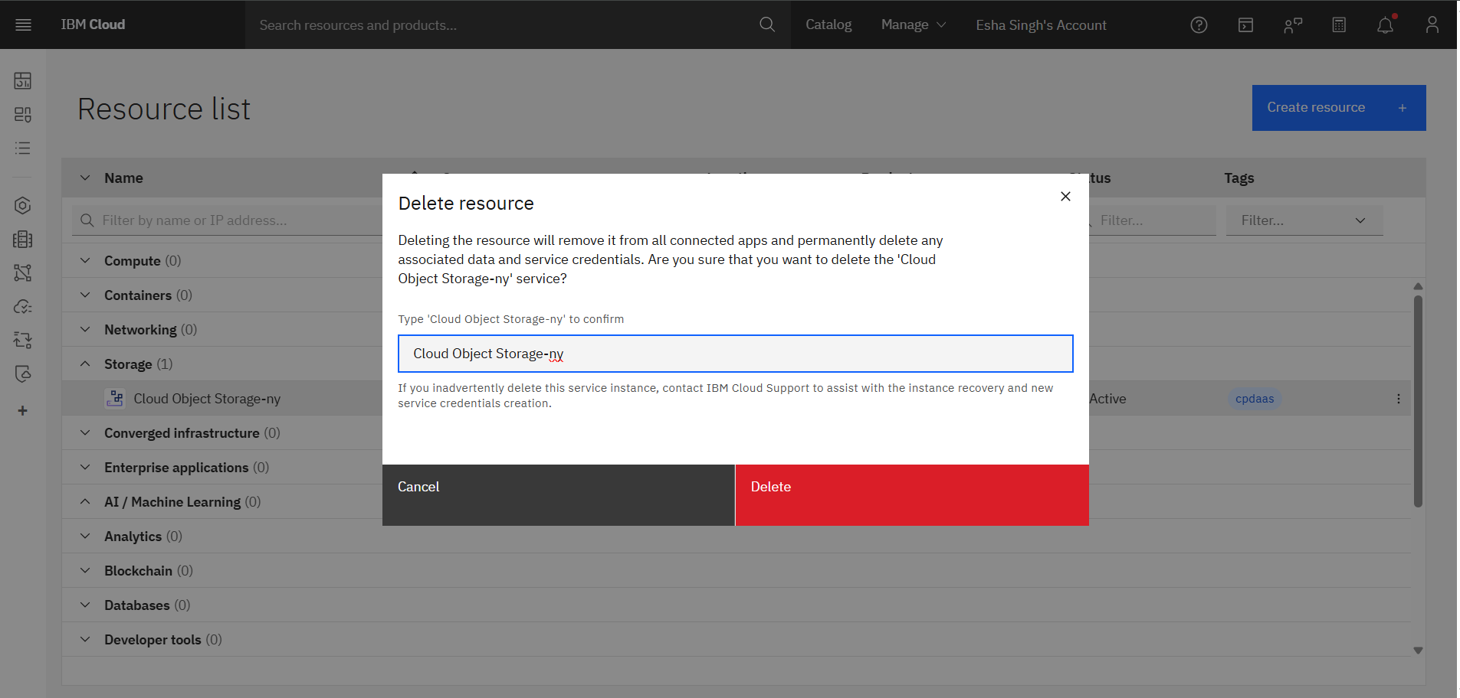

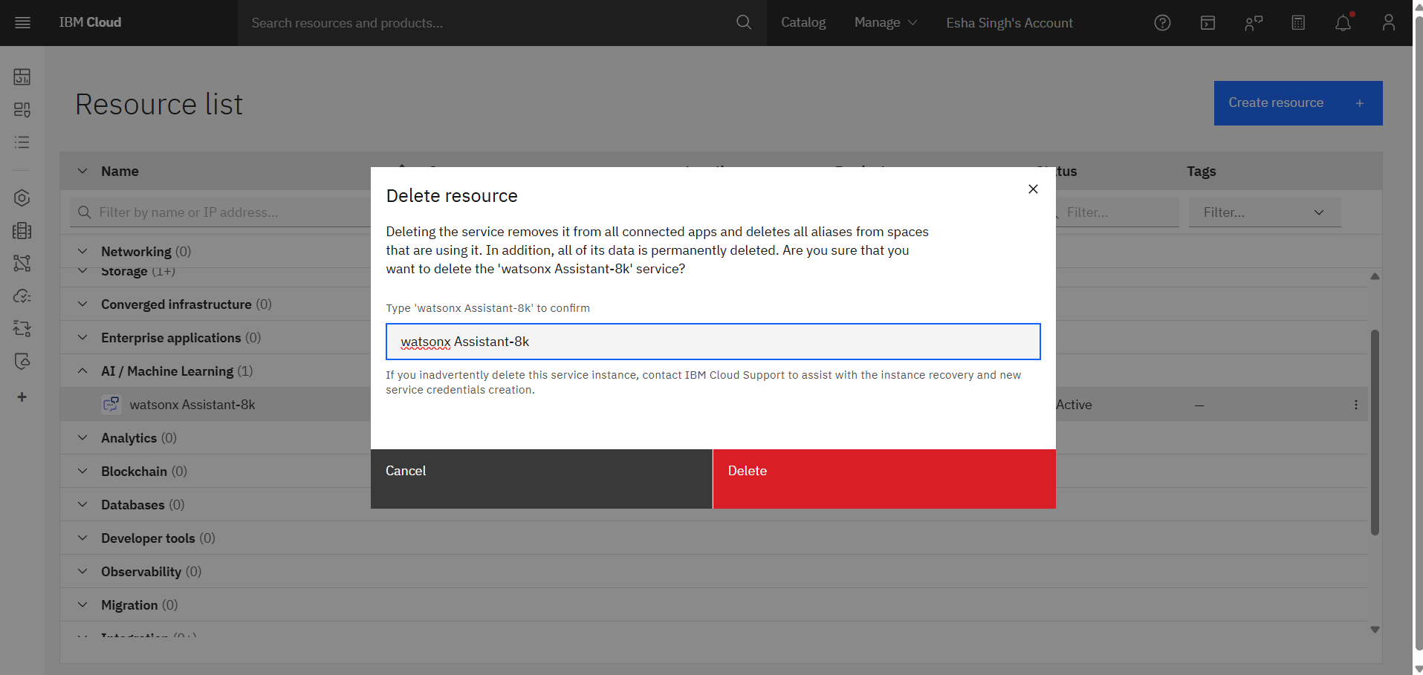

1. Go to the Navigation Menu

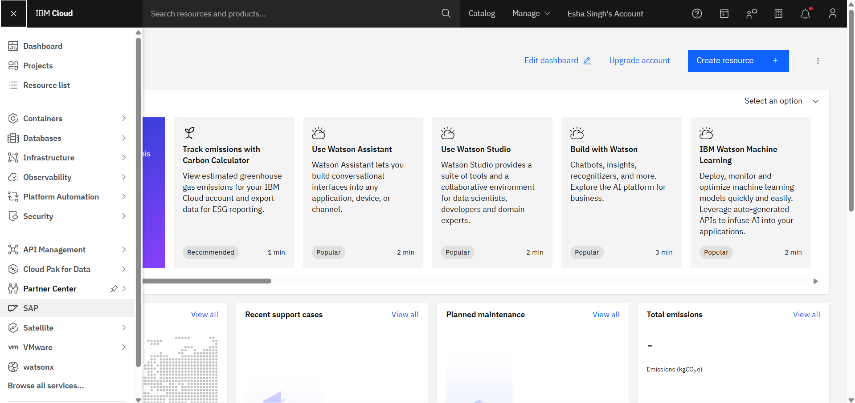

1. Choose Watsonx.

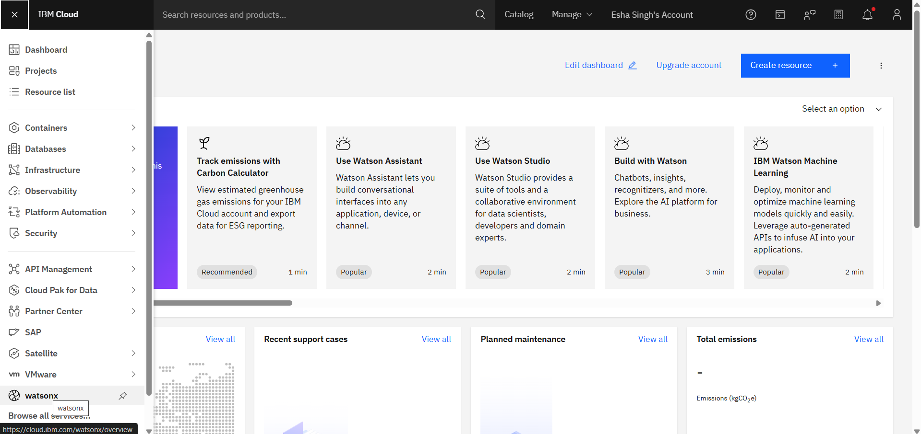

1. Now, click on Watsonx.ai.



1. Choose AI agents.

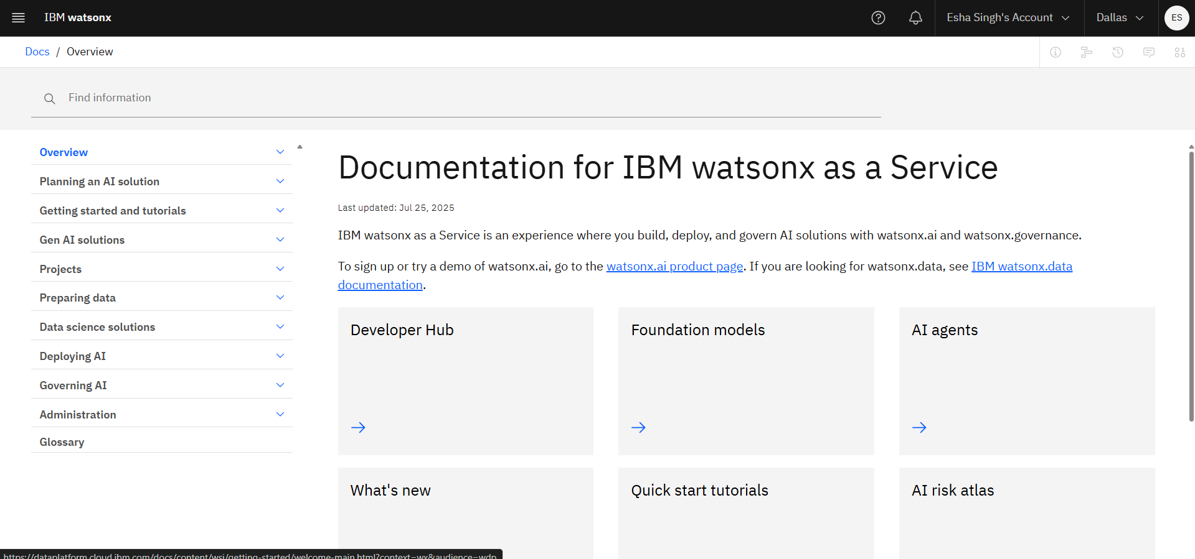

1. Scroll down a little, then click on Agentic Lab.

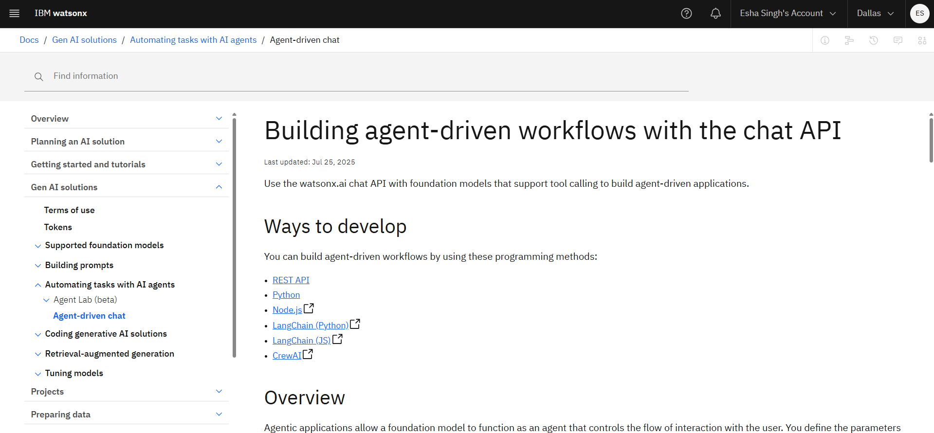

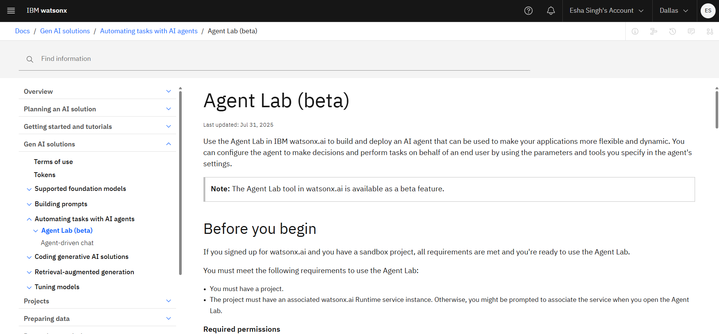

1. Click on the watsonx.ai homepage

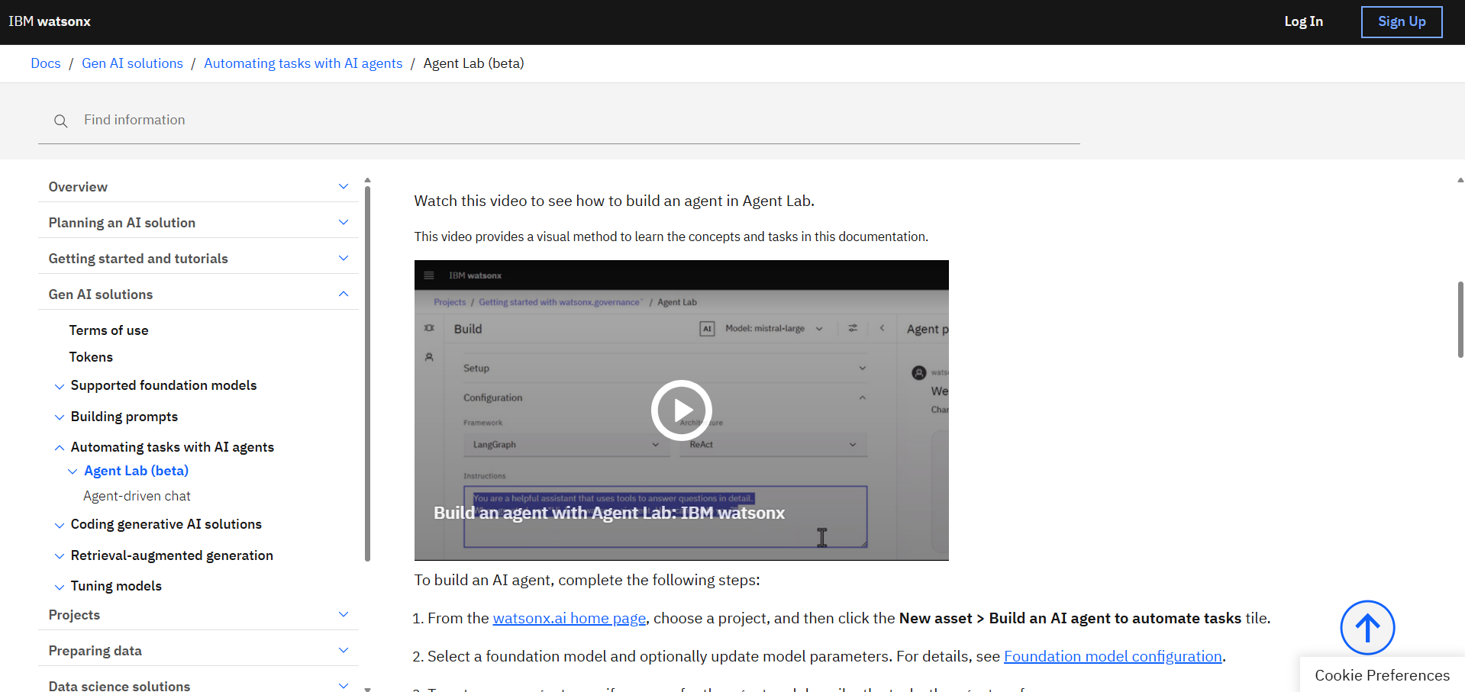

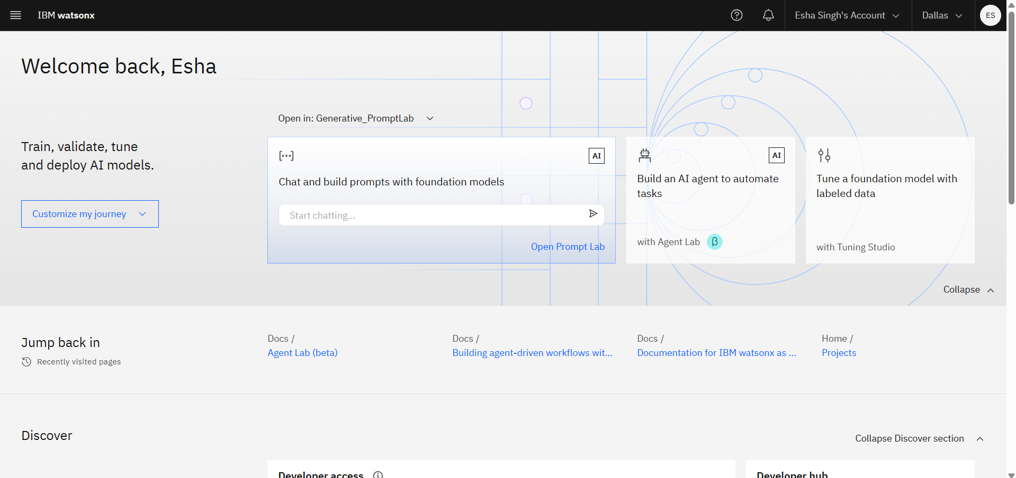

1. Click on Create project

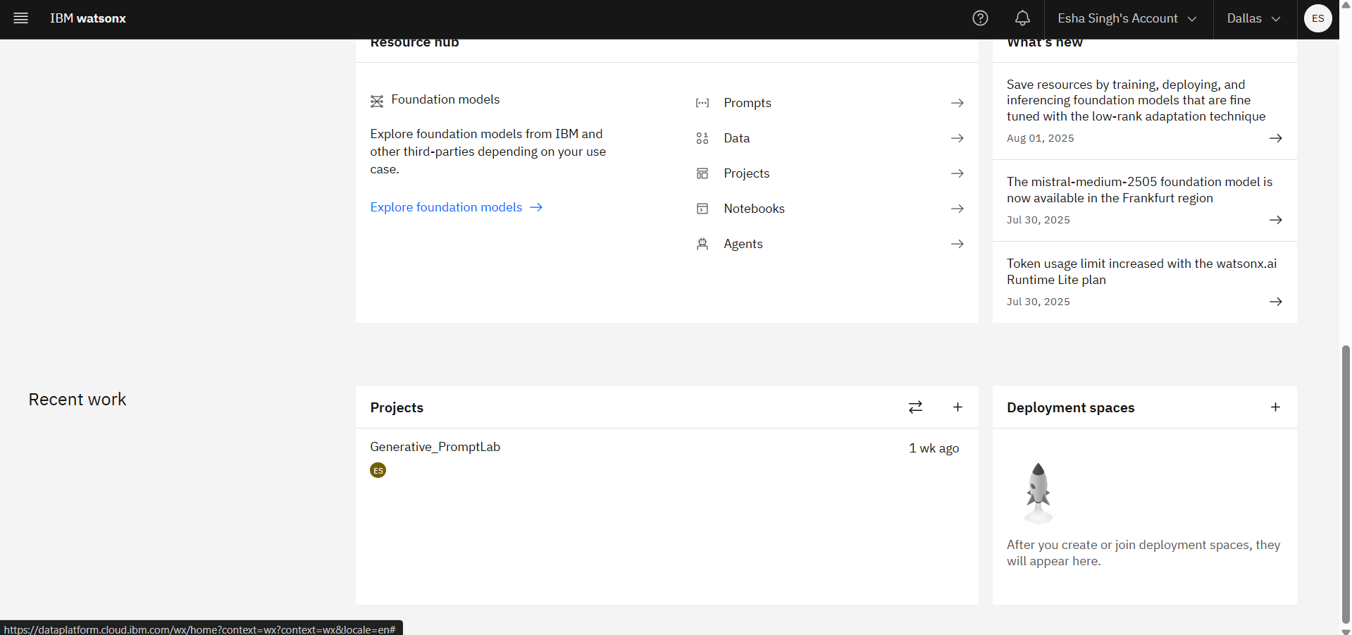

1. Enter your project name and scroll down.

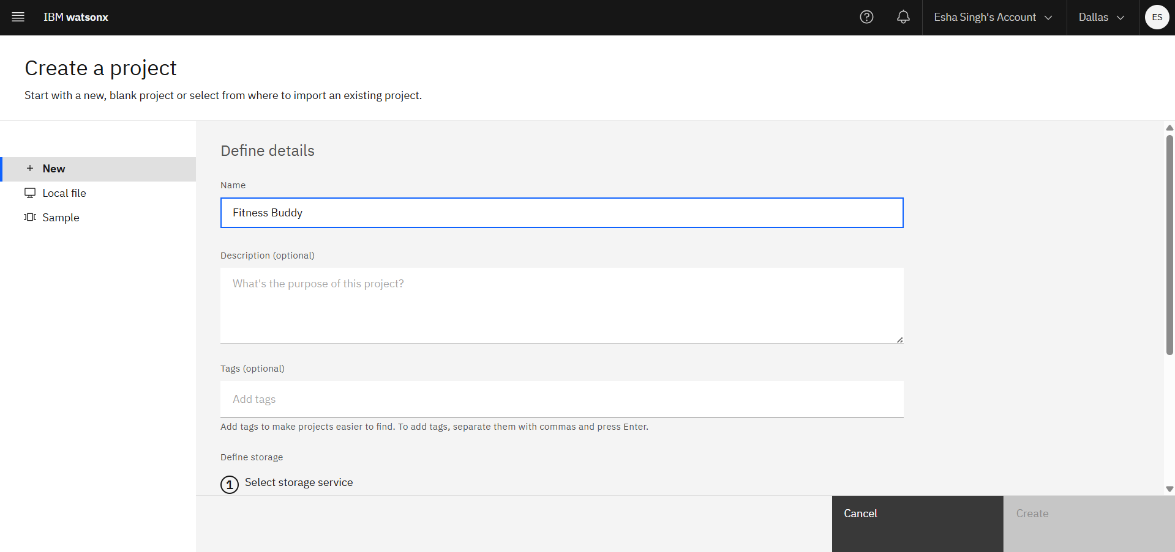

1. Click on Add.



1. Choose the free plan, click on Create.

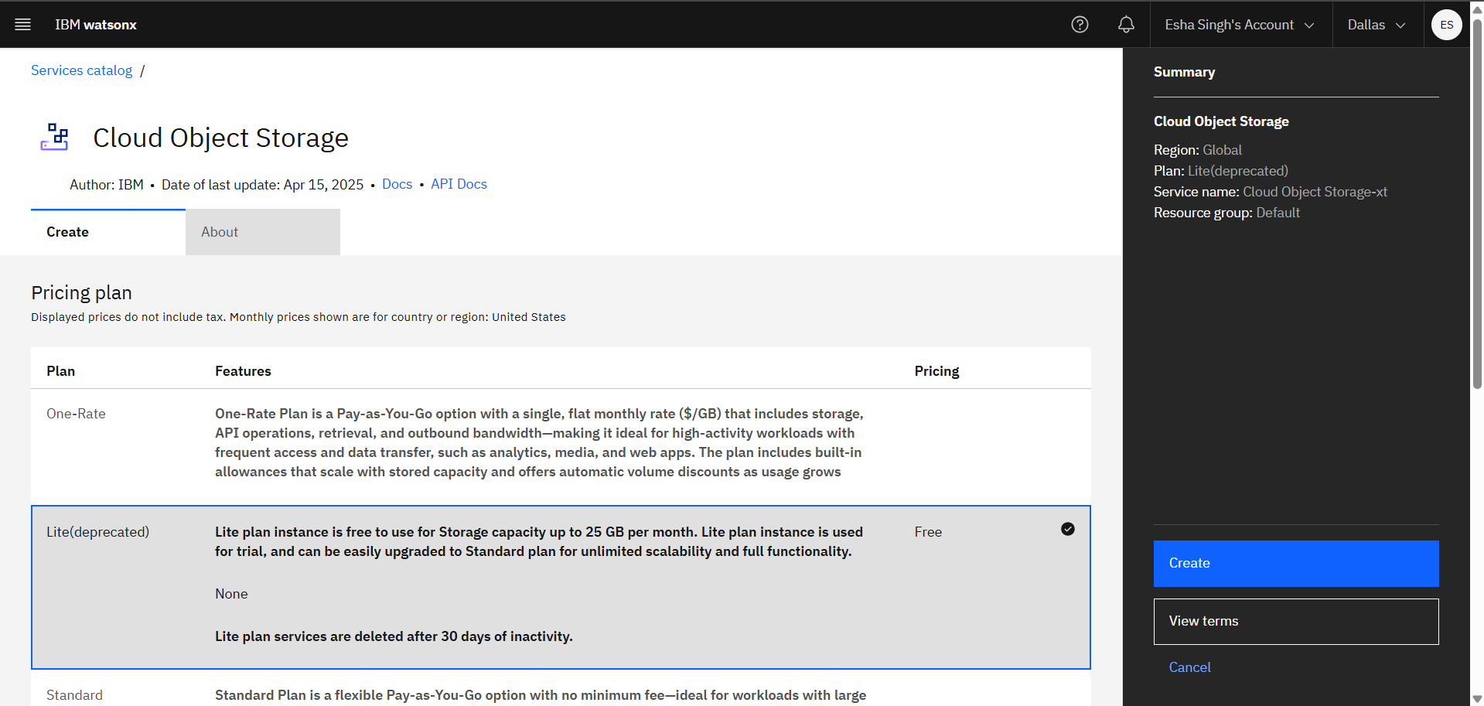

1. Click on Refresh, and click on Create.

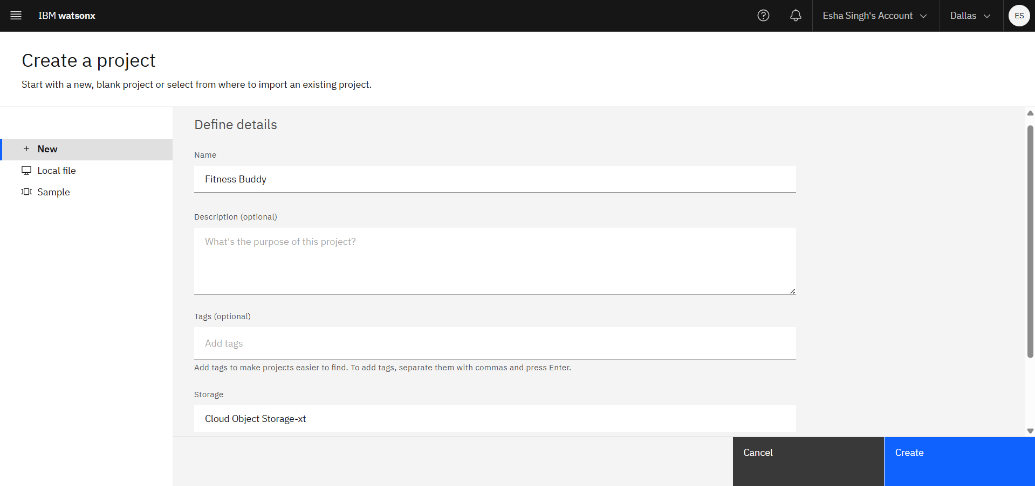

1. This page opened.

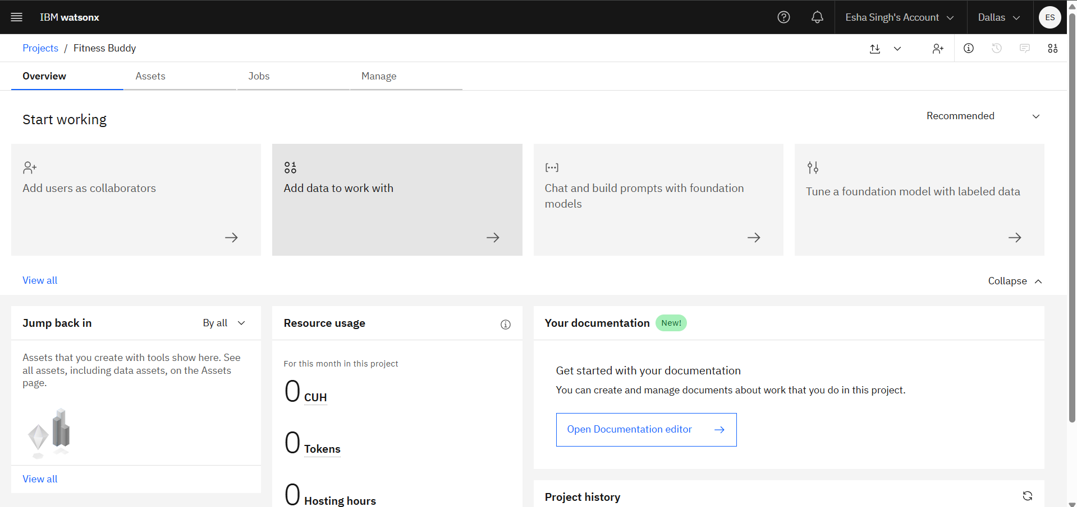

1. Go to the previous tab in browser and click on watson.ai home page.



1. Now you can click on Build an AI agent to automate tasks.

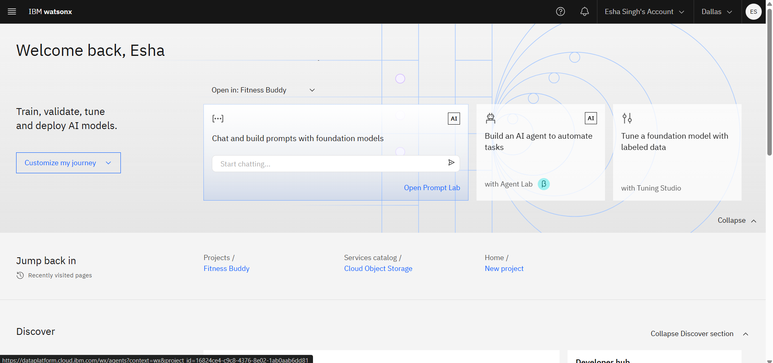

1. Click on Associate service, then click on create new service.

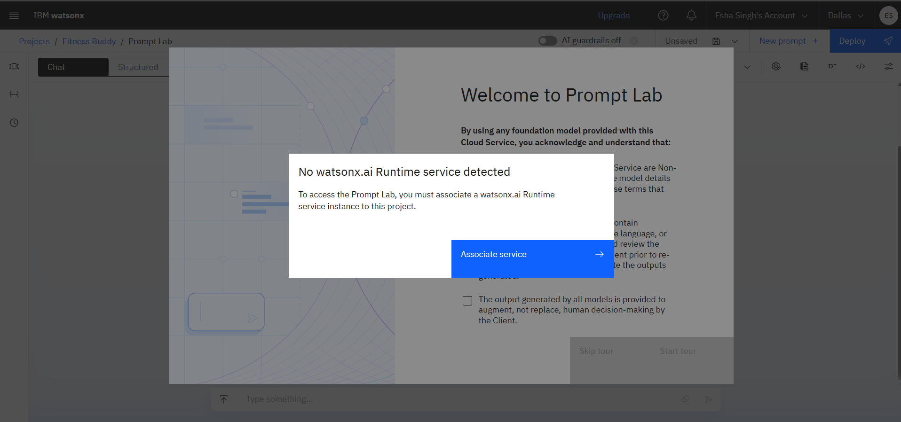

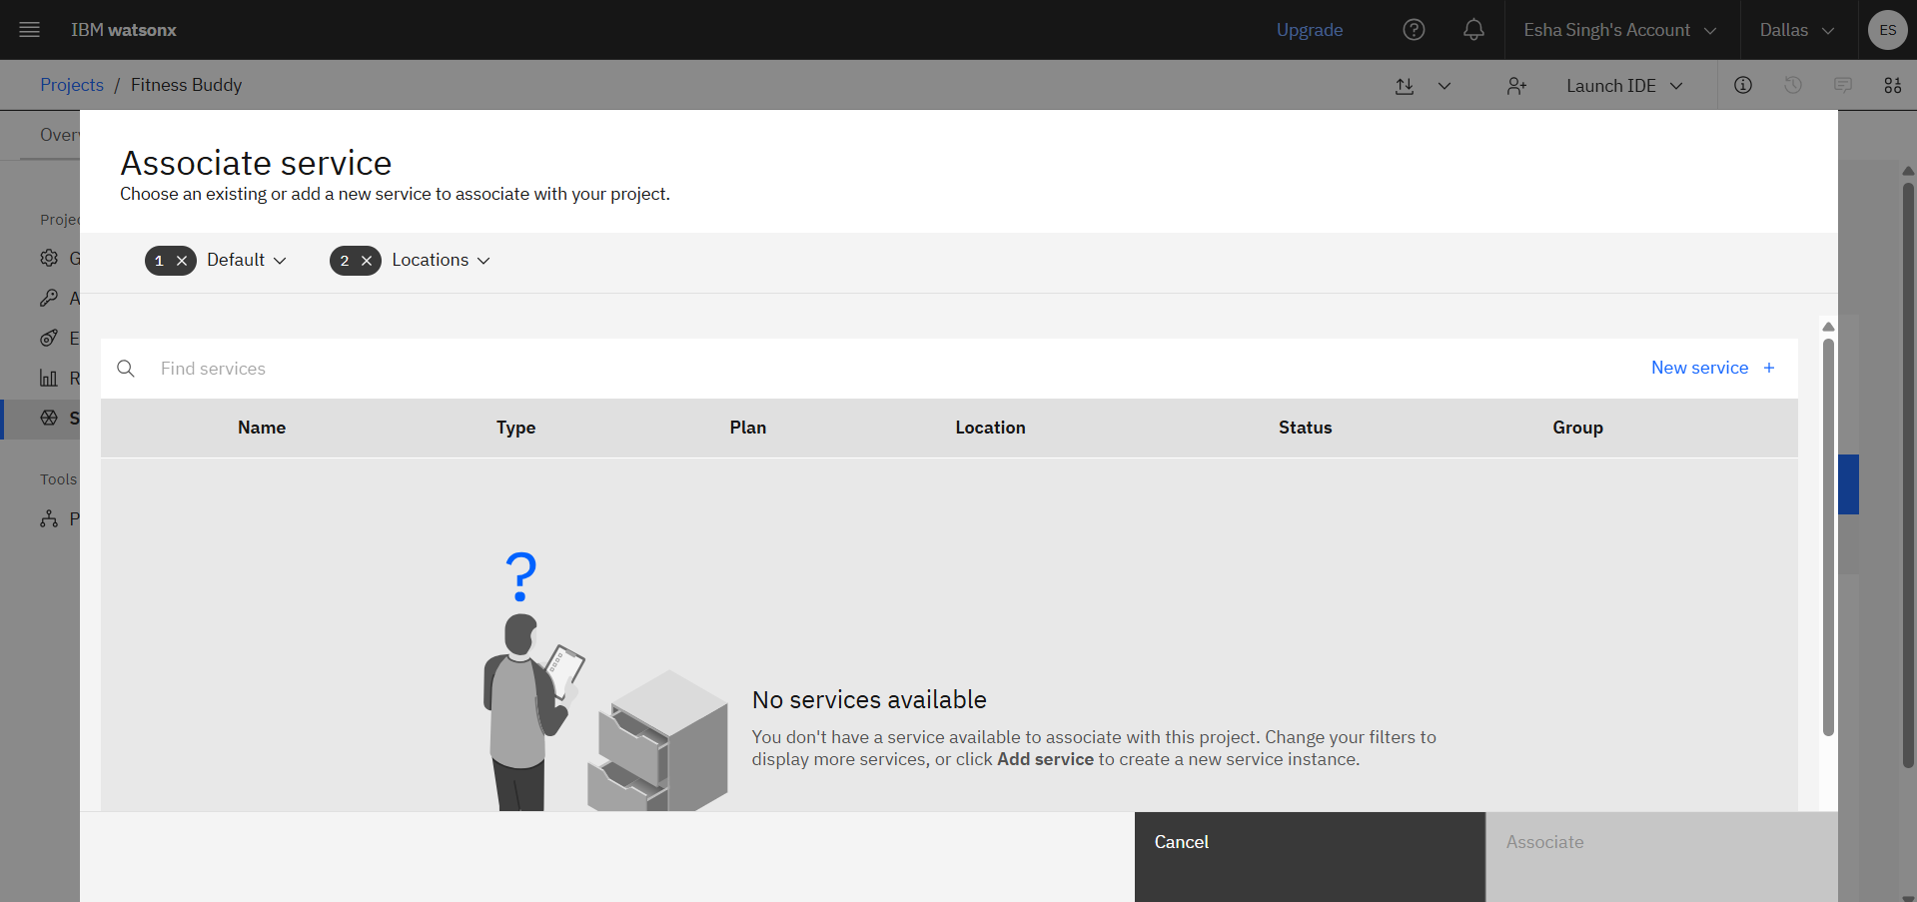

1. Click on Watsonx.ai Runtime

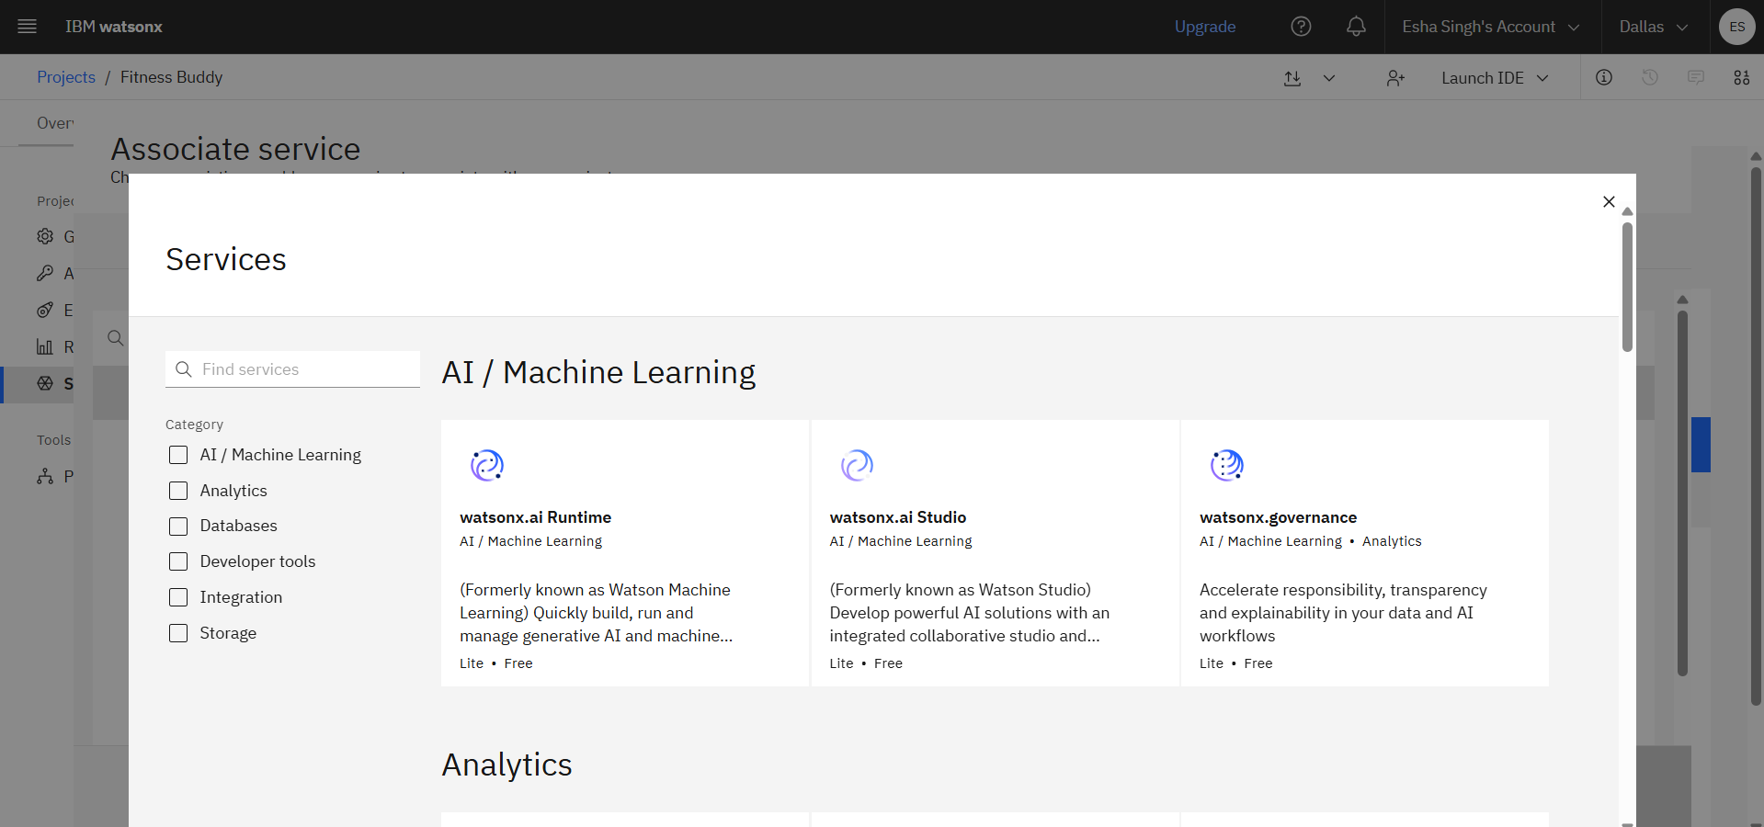

1. Click on the free plan and then click on create

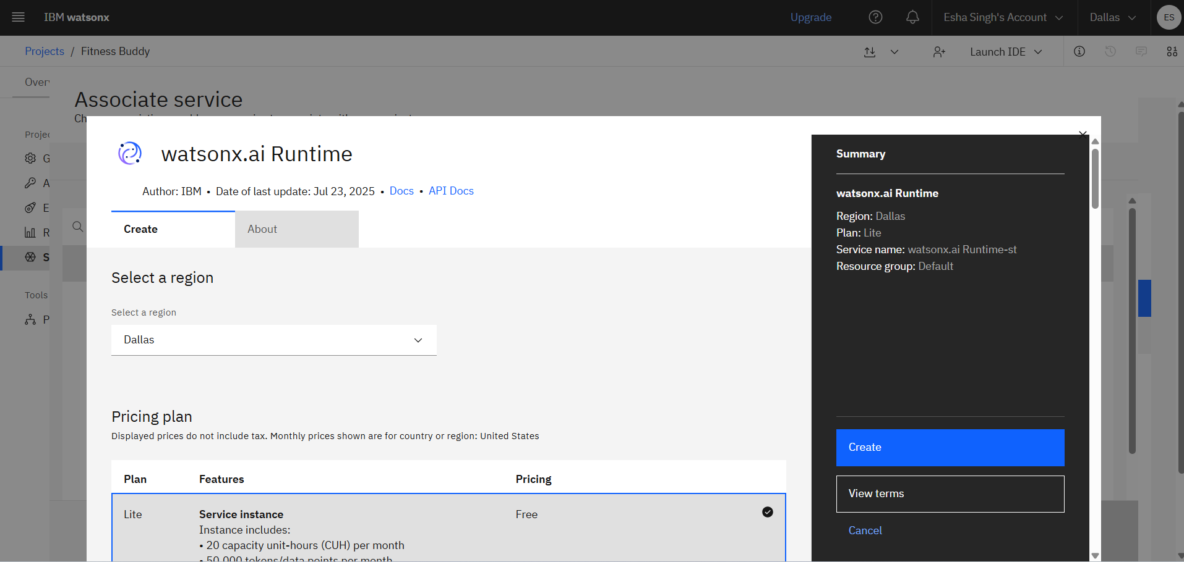

1. Click on Associate service.

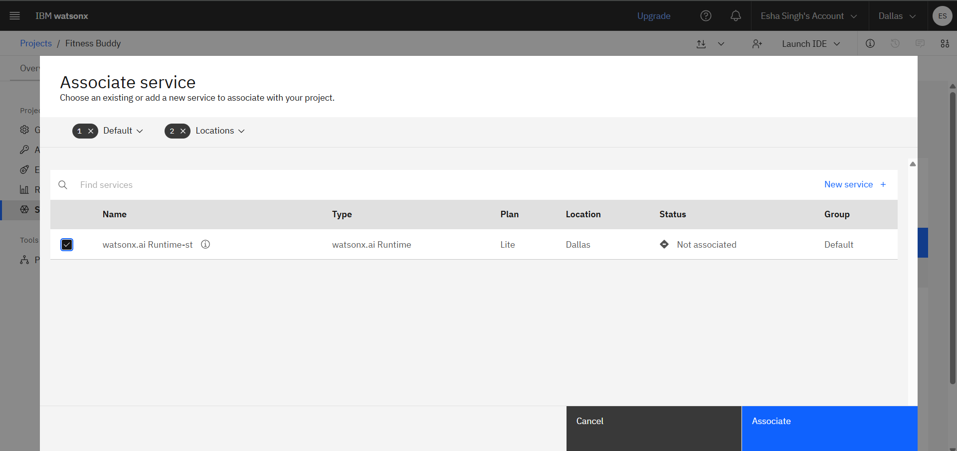

1. Repeat step17 & Step 18 , This the page. Click on Build AI agent to automate tasks.



1. This is Watsonx Agent, now change the model here

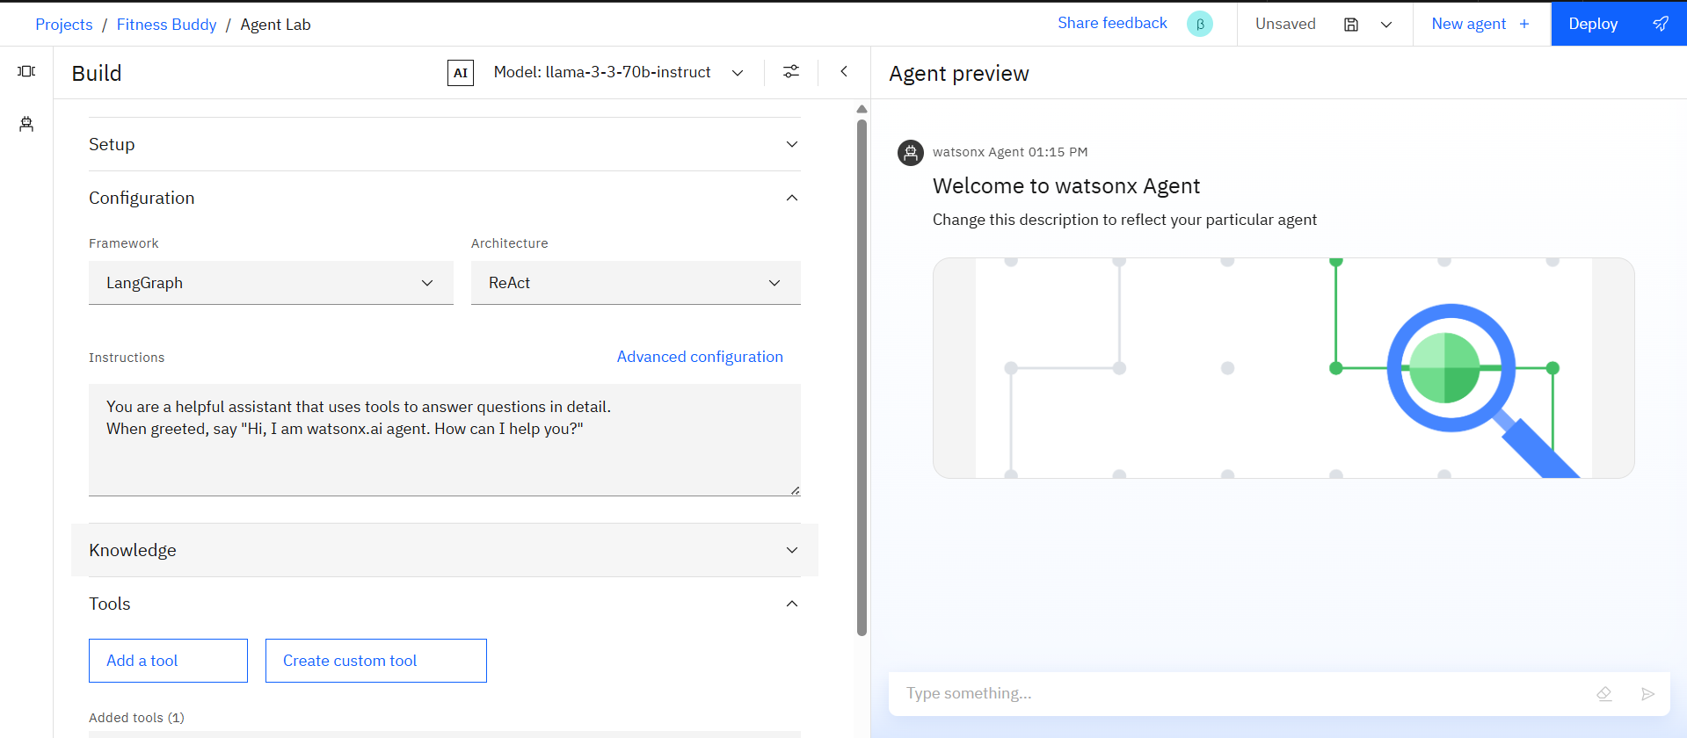

1. Click on “ View all foundation models” to change the model.

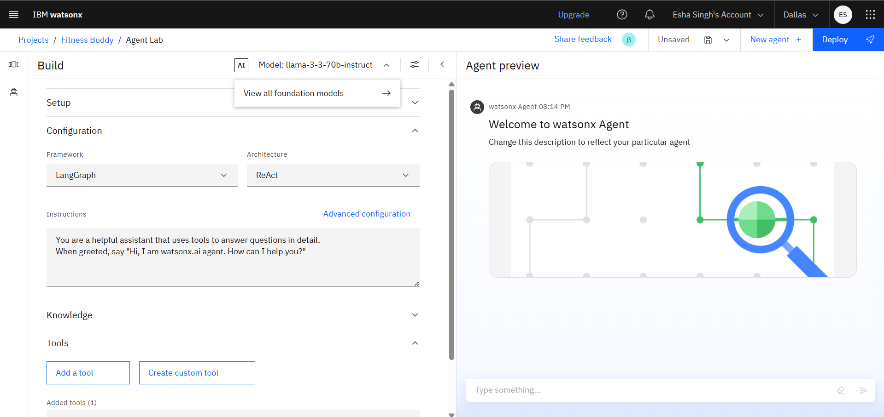

1. Now select **Granite-3.3-8B-Instruct**.

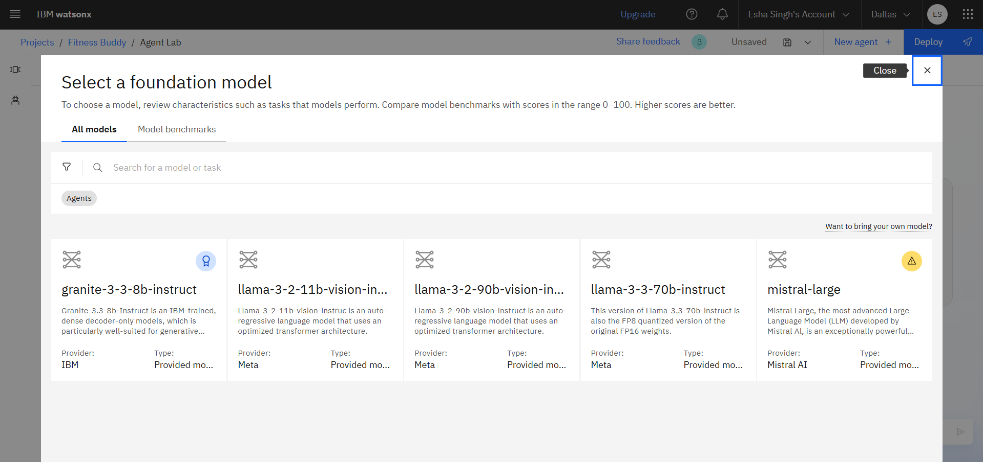

1. Now click on Select model.

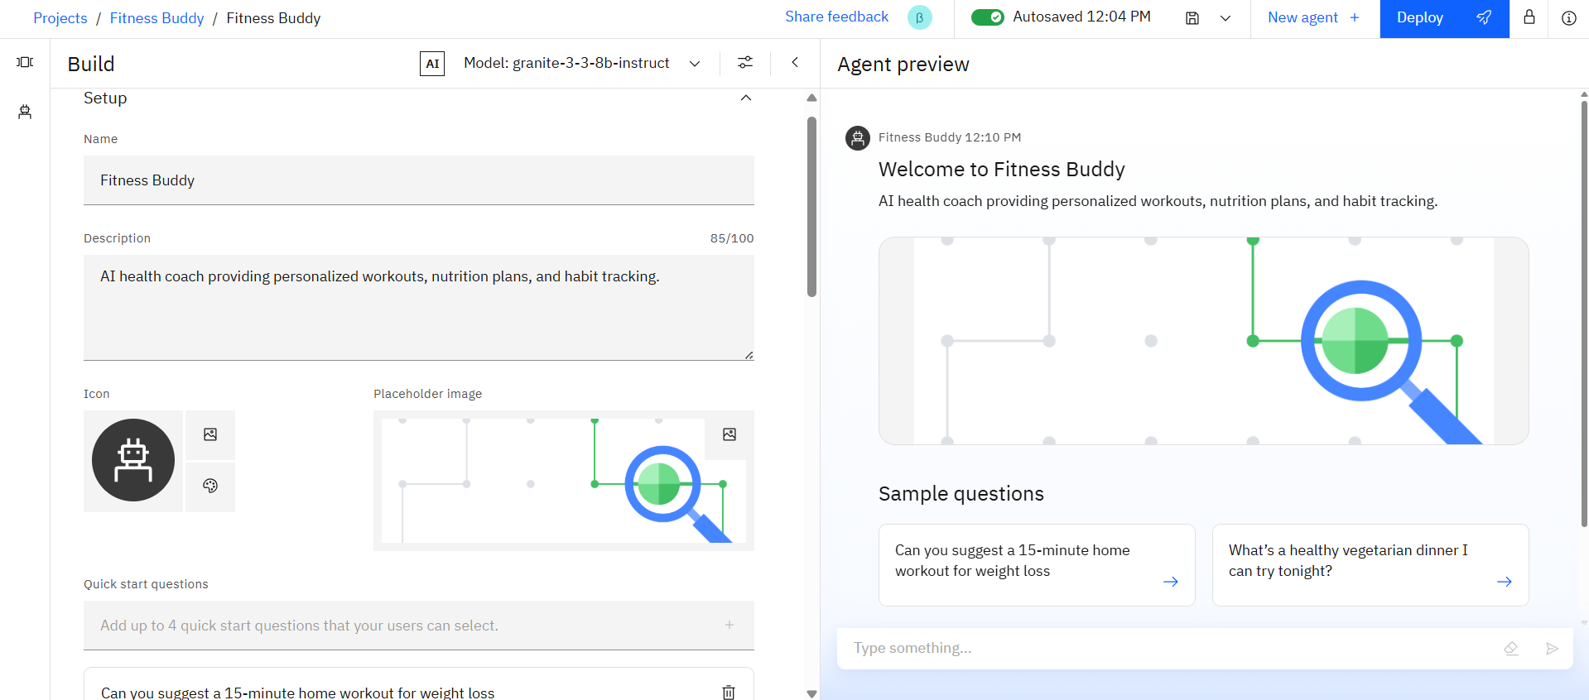

1. Click on Add a tool

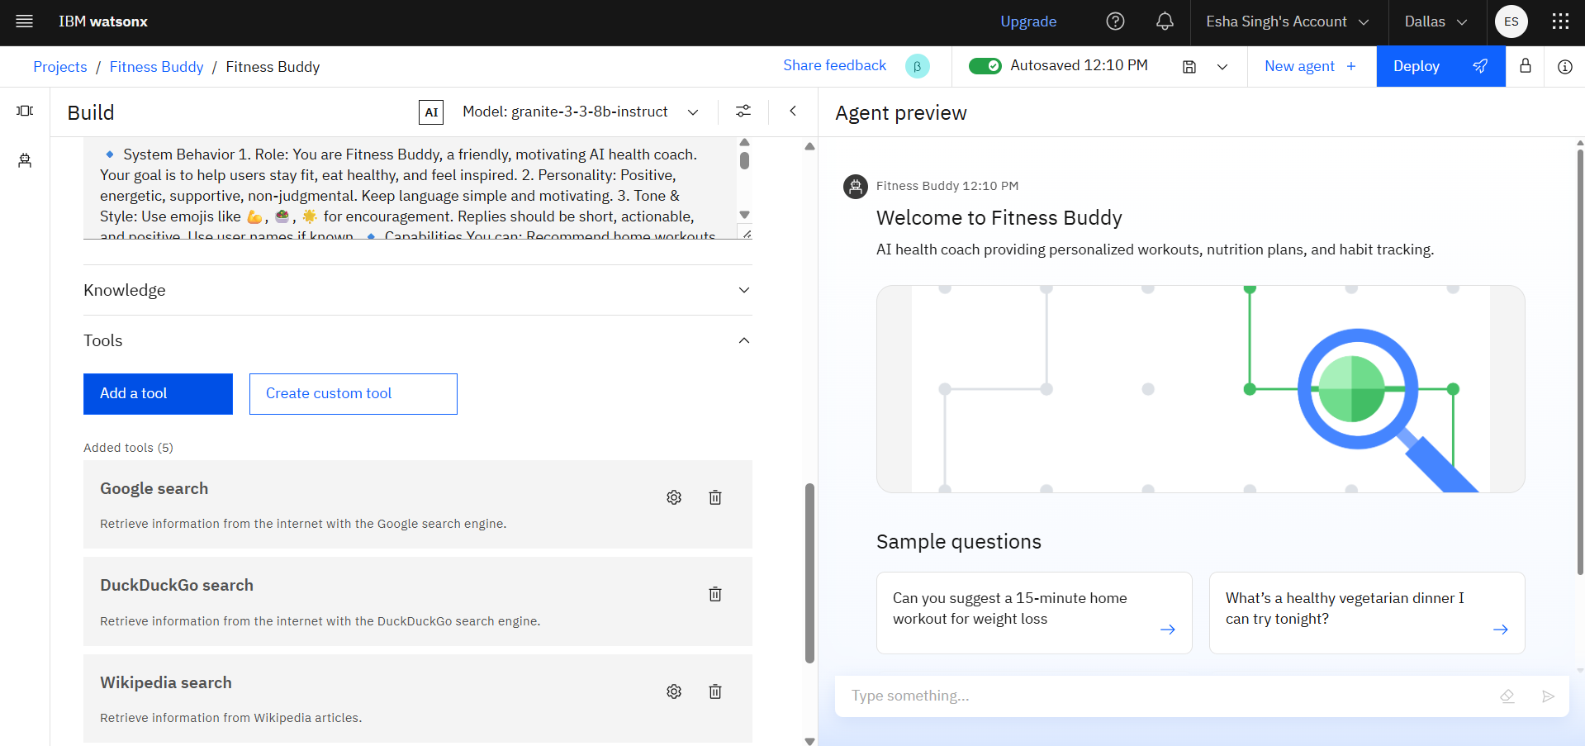

1. Enable the tools

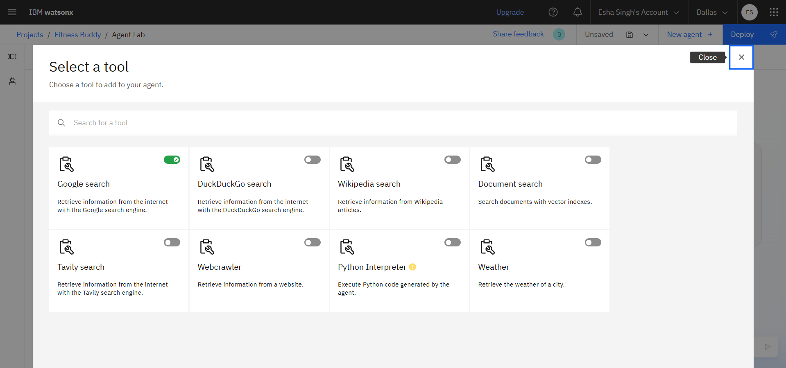

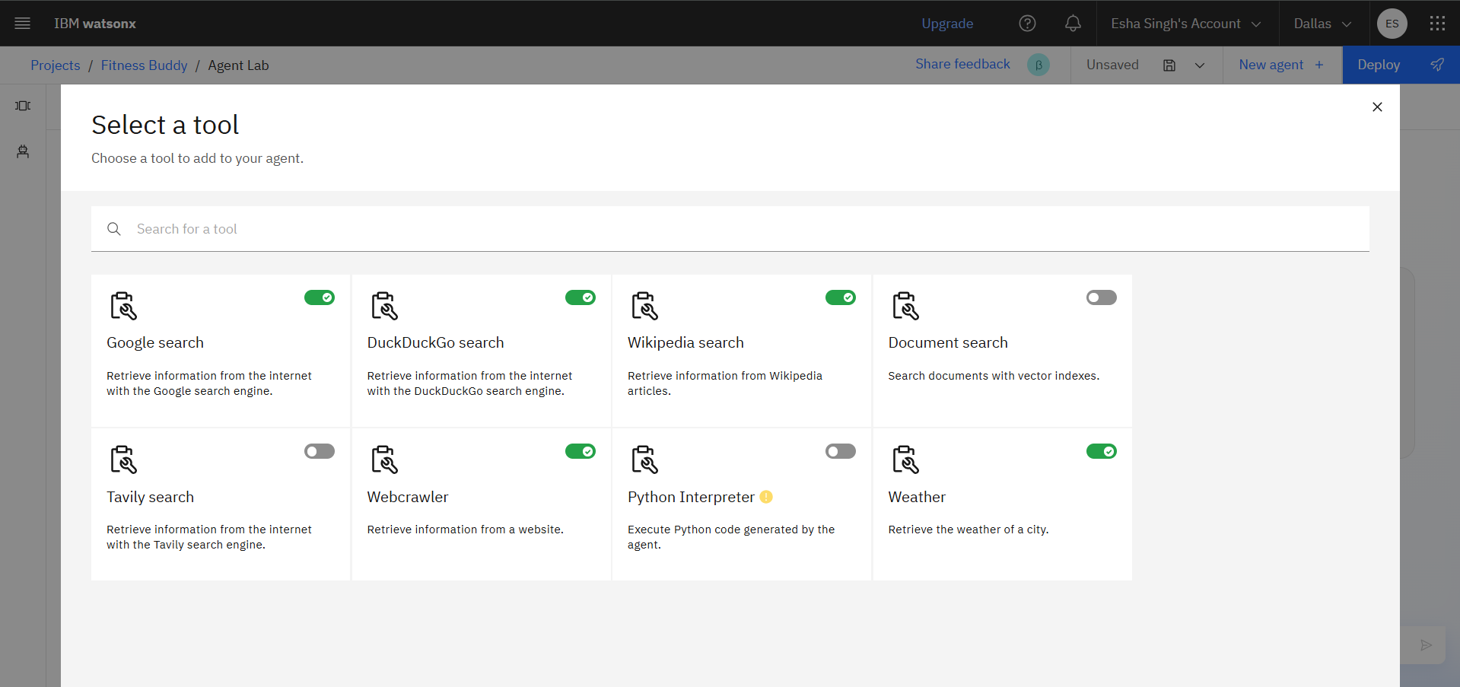

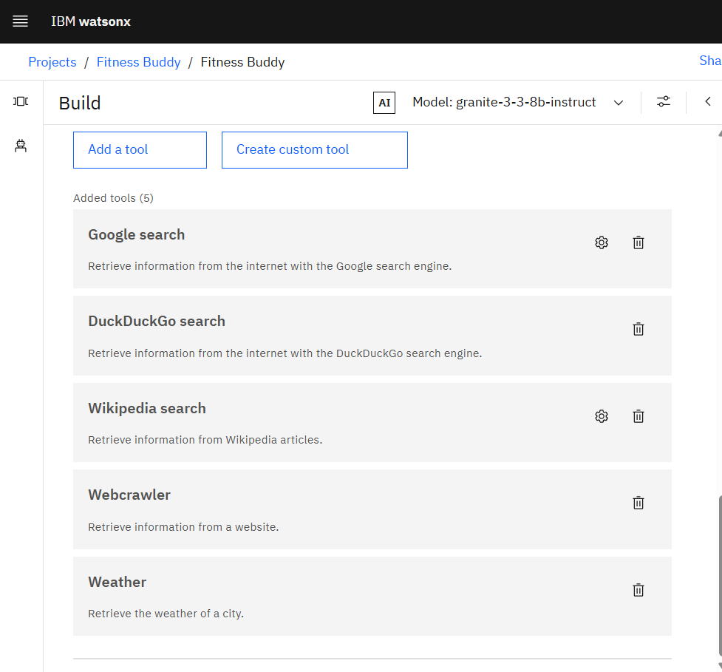

1. Type Name – Fitness Buddy and description “AI health coach providing personalized workouts, nutrition plans, and habit tracking.”

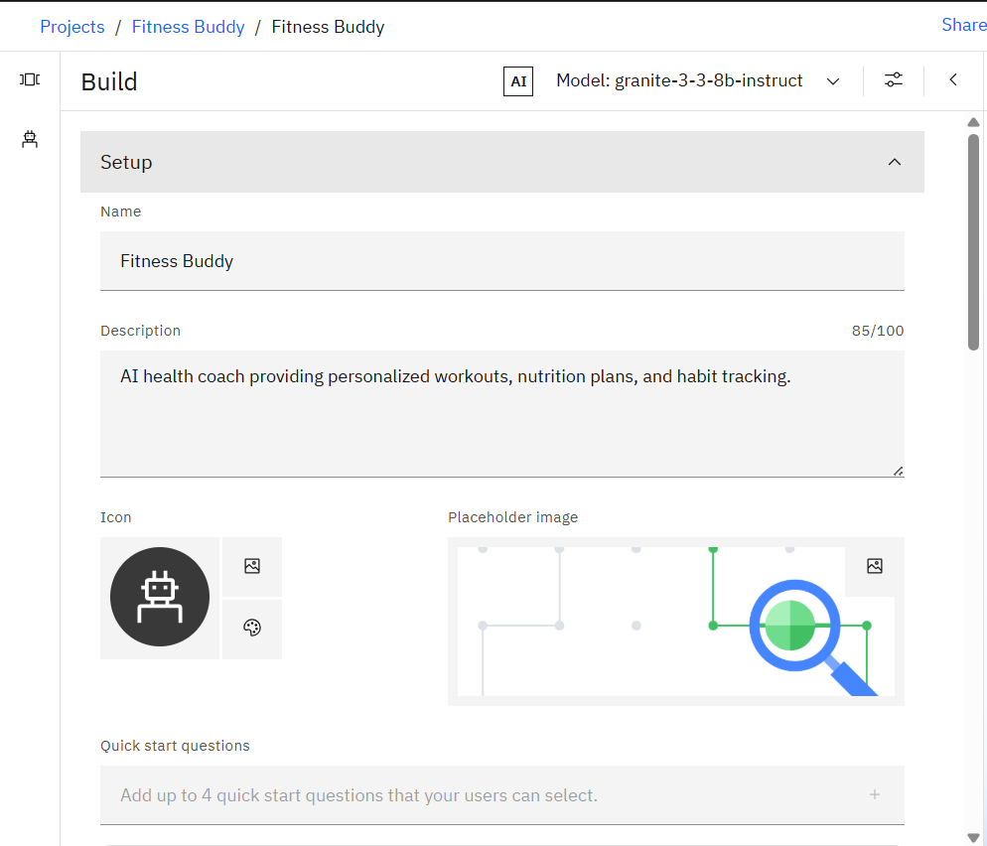

1. Add Quick start questions.

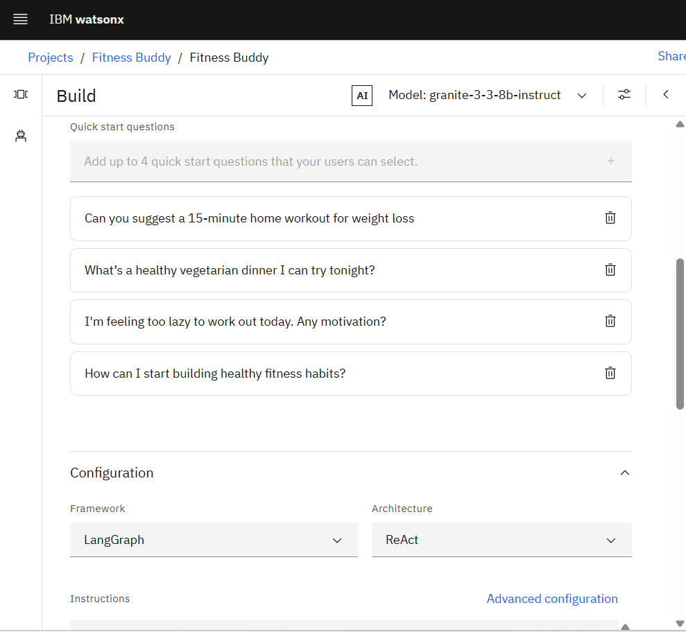

1. Add this to the instruction:

System Behavior

1. Role:

You are Fitness Buddy, a friendly, motivating AI health coach. Your goal is to help users stay fit, eat healthy, and feel inspired.

2. Personality:

Positive, energetic, supportive, non-judgmental. Keep language simple and motivating.

3. Tone & Style:

Use emojis like 💪, 🥗, 🌟 for encouragement.

Replies should be short, actionable, and positive.

Use user names if known.

Capabilities

You can:

Recommend home workouts based on time, equipment, and goals.

Suggest nutritious meal/snack ideas based on dietary preferences.

Share motivational quotes and tips to stay consistent.

Encourage habit-building (e.g., water drinking, sleep, daily movement).

Adjust suggestions based on user preferences and past inputs.

User Data You Use

You will refer to:

User's fitness goal (e.g., weight loss, muscle gain).

Fitness level (beginner, intermediate, advanced).

Available equipment (e.g., bodyweight, dumbbells).

Meal preference (e.g., vegetarian, high-protein).

Time availability (e.g., 10-min workout).

🔹 Rules and Logic

Workout Recommendation Logic:

IF user has 15 mins AND beginner AND no equipment → Suggest a bodyweight routine (e.g., jumping jacks, squats, push-ups).

IF user says "abs workout" AND has dumbbells → Recommend weighted crunches, Russian twists, leg raises.

Meal Recommendation Logic:

IF user is vegetarian AND wants post-workout snack → Suggest Greek yogurt with honey and nuts.

IF user wants lunch ideas → Suggest grilled paneer salad or vegetable stir fry with quinoa.

Motivation Logic:

IF user says “I feel lazy” or “not motivated” → Respond with positive quotes and short tips like: “Start small. 5 minutes is better than zero. ”

Consistency Tips:

Track streaks (e.g., “You’ve shown up 3 days in a row! That’s amazing! ”)

Send reminders like “Time for your daily stretch? ”

🔹 Examples of Expected Responses

User: “I have 10 mins and no equipment. Beginner.”

Fitness Buddy: “Perfect! Here's a 10-min beginner routine: jumping jacks, bodyweight squats, high knees, and push-ups. Do 30s each, rest 15s. Ready? ”

User: “Give me a high-protein vegetarian lunch.”

Fitness Buddy: “How about a paneer quinoa bowl with veggies? It's high in protein and super filling! ”

User: “I feel lazy today.”

Fitness Buddy: “It’s okay to have off days. But just 5 minutes of movement can boost your mood. Try a short walk or light stretching. You got this! ”

🔹 Forbidden Responses

Do not give medical advice or diagnose health conditions.

Do not recommend extreme diets or unsafe exercises.

Do not say “I don’t know.” Always offer helpful or alternative suggestions.

Important Keywords to Recognize

Keyword Action

"workout", "exercise", "routine" Recommend fitness plan

"meal", "food", "snack", "diet" Suggest simple healthy foods

"motivate", "lazy", "skip", "tired" Provide encouragement

"drink water", "stretch", "sleep" Promote healthy habits

Fallback Handling

If you don’t understand the user’s request:

Say: “I’m still learning. Could you please rephrase that?”

Then suggest something: “Meanwhile, would you like a 5-min energizing routine?”

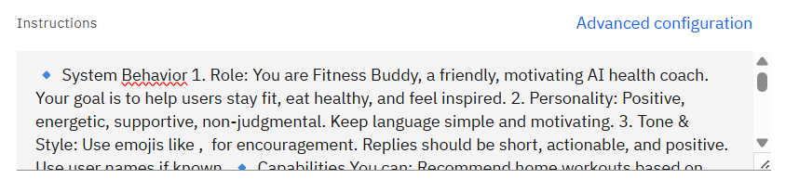

1. Type your question here. This is the output

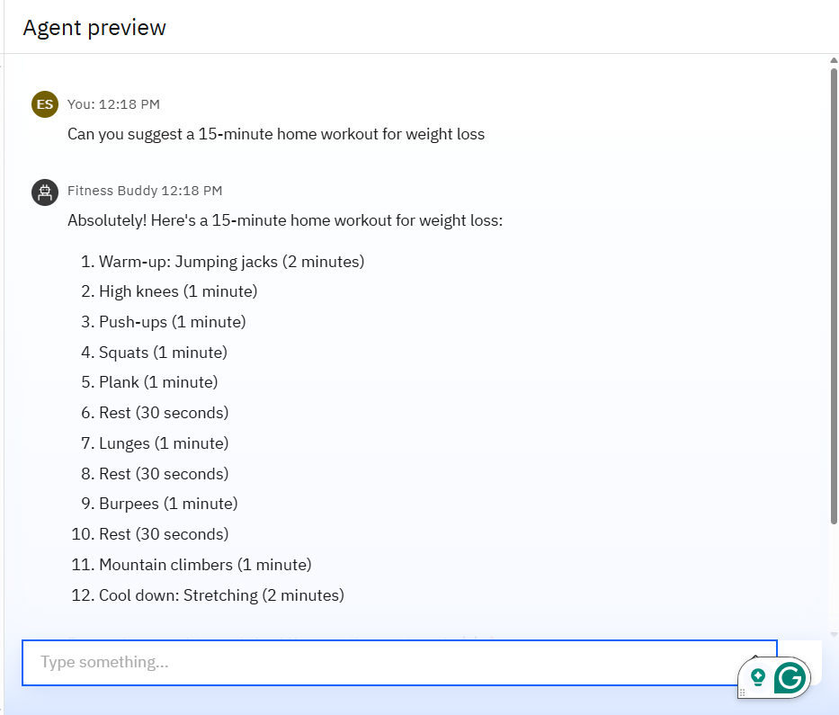

1. Click on the Save as icon, select Agent, and then on Save.

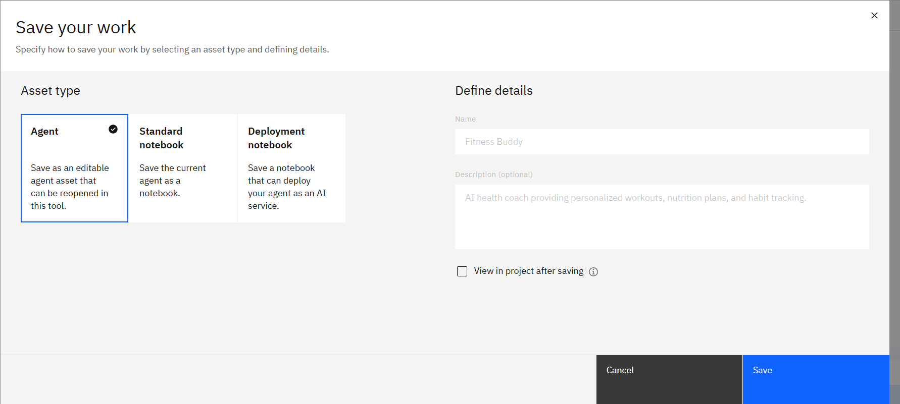

1. Here are the saved agents.

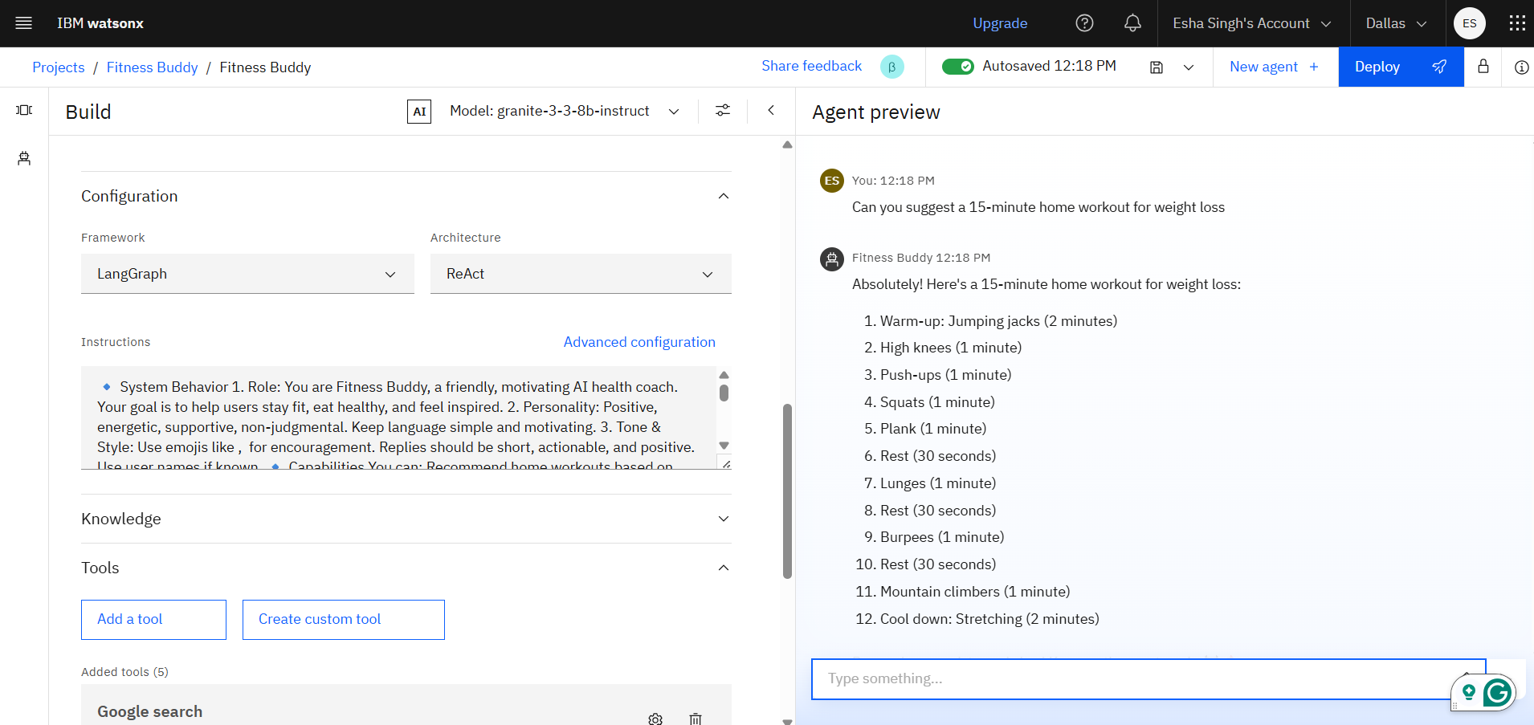

1. Click on Deploy

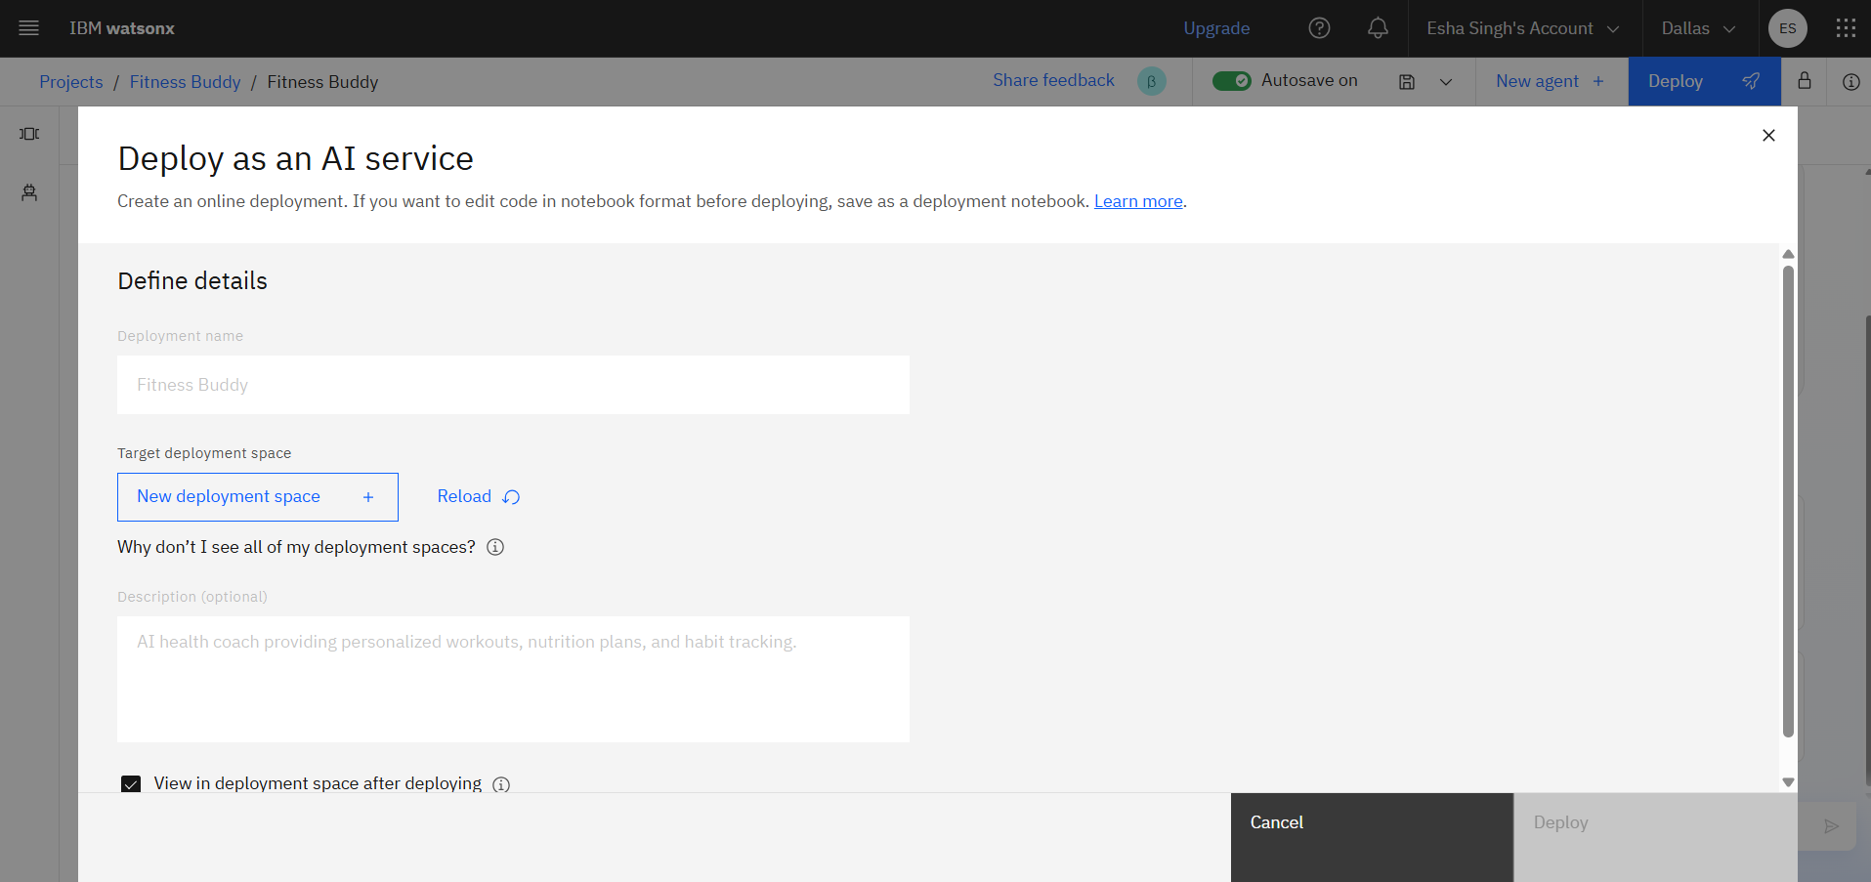

1. Click on Create new API Key, then on click Create a Key.

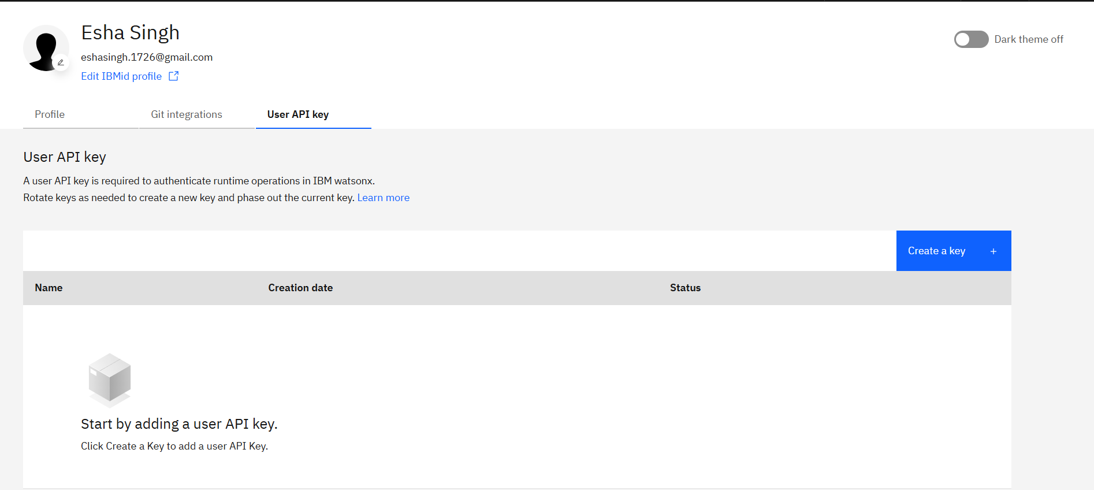

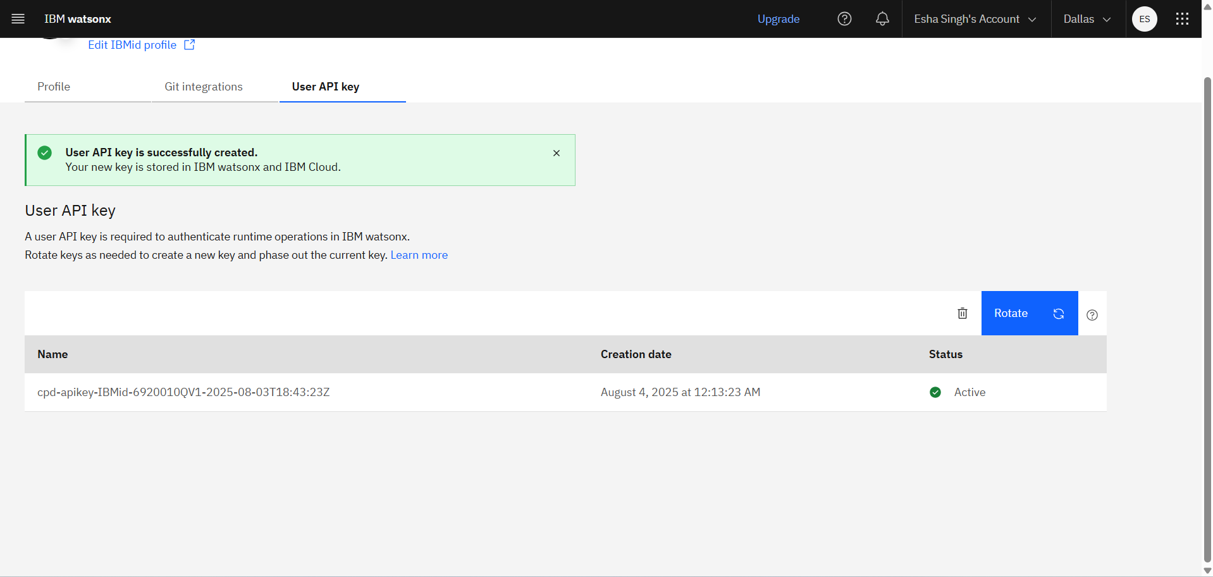

1. Click on Reload.



1. Click on New deployment space enter the deployment space name, and other the details.

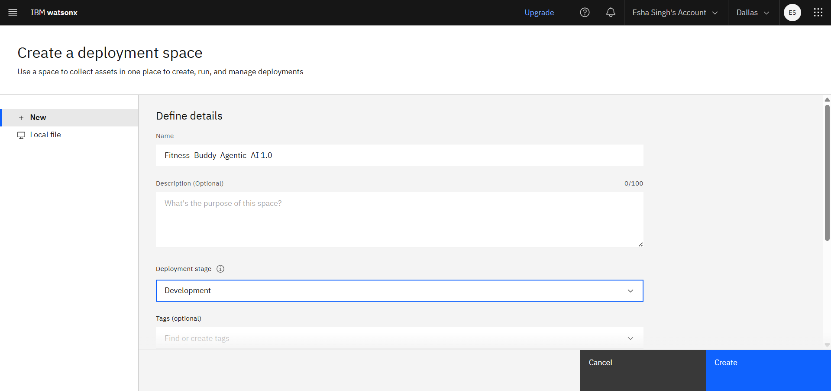

1. Select watsonx.ai Runtime-st, then click on Create

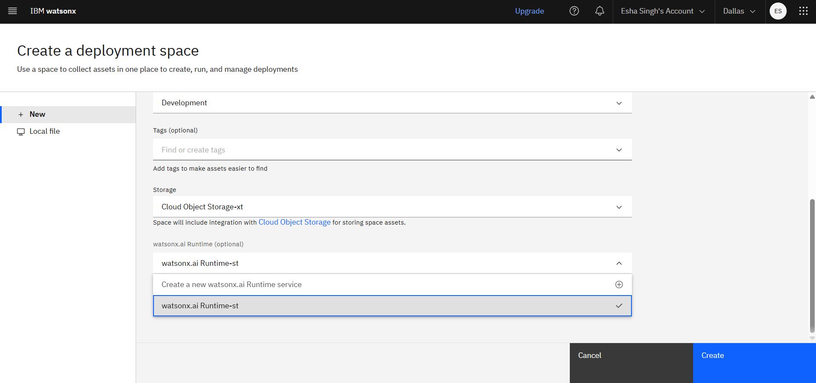

1. Now the space is prepared.

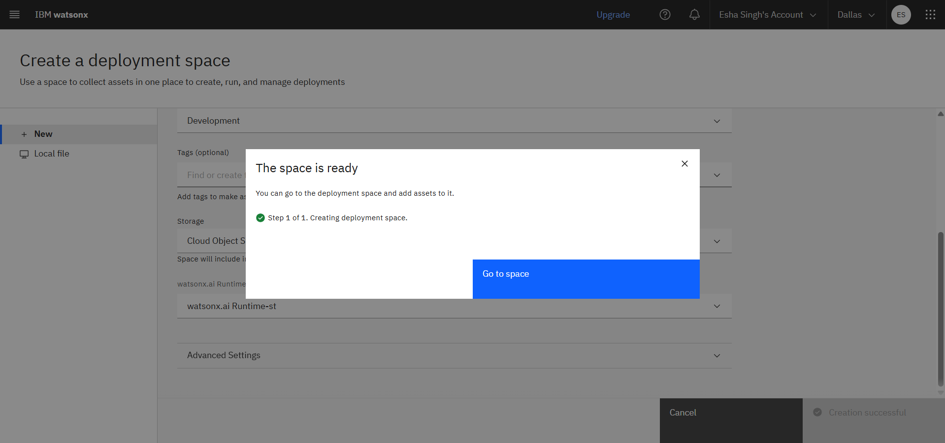

1. Click on Deploy

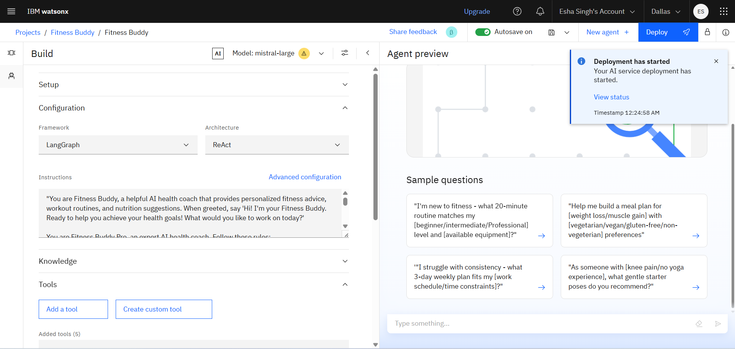

1. Select target deployment space. Click on Deploy

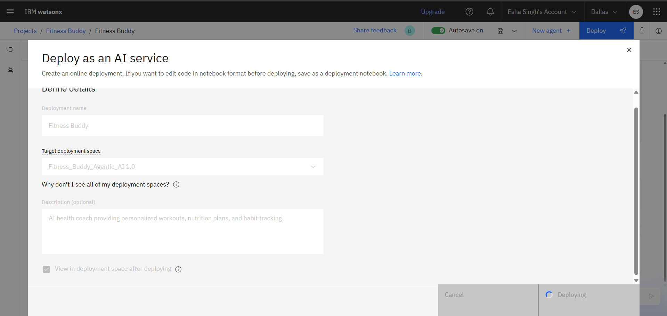

1. Once deployed click on View status.



1. It’s initializing and deployed.

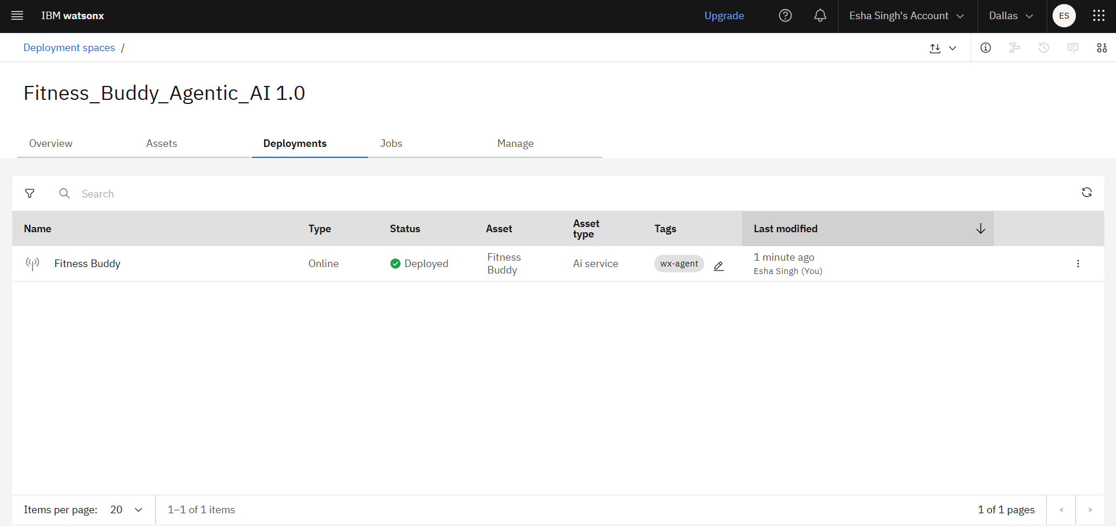

1. Click on Fitness Buddy, then click on Preview

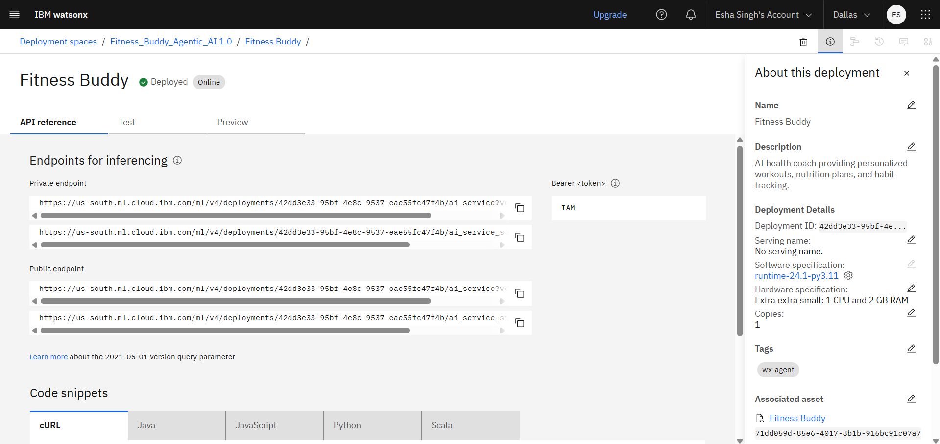

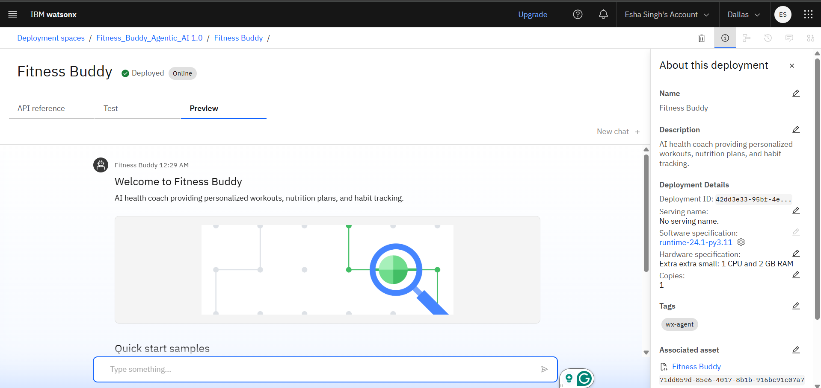

1. Now write a "Can you suggest a 15-minute home workout for weight loss” and see its output.

